-: CURRICULUM VITAE :-

Joy Roy :  Mobile :- +91 9903715292  Email Address :- jroy72@gmail.com | 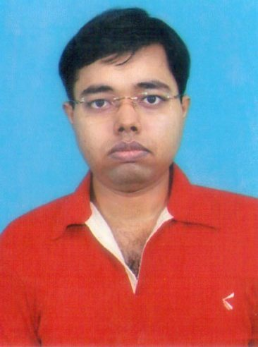

- CAREER OBJECTIVE :-
Looking forward to a glorious & bright career, willing to work with an esteemed organization in a creative & challenging workplace, where I can emphasis my management knowledge & interpersonal skills that would provide me the opportunity to contribute to business growth of my organization, learn new skill & explore future career possibilities.
- EDUCATIONAL QUALIFICATION :-

- B.com from Calcutta University, year 2009.
- MBA (2 year full time) from JIS College (Centre for Management Study) presided by West Bengal University of Technology (W.B.U.T.), year 2013 and my specialization paper is Finance and marketing.

- IT EXPOSURE:
- Basic computer knowledge and internet surfing.
- MS OFFICE 2007, EXCEL2007.

- OPERATING SYSTEM-XP, WINDOWS 7.

- WORK EXPERIENCE :-

- PROJECT EXPERIENCE:
- Complete my Summer Internship Program of 2 months duration from “Mother Diary” to analyses the working capital of the company.
- Entrepreneurship Development programed under MSME (Govt. of India)

- Executive:
- Ex. Financial Planning Executive of Bajaj Capital limited.
- Ex. H.R & Administrative Manager of L.R. Logistics (service Provider Company).
- Marketing Executive of Vidisha Electricals Pvt. Ltd. FMCD (Fan production company )

- PERSONAL PROFILE :-
- Name : Joy Roy.
- Father’s Name : Jahar Roy.
- Date of Birth : 9th April, 1986.
- Marital Status : Single.
- Residence : C3M1 302 CMDA Nagar, Barrack pore, Kolkata,
24 PGS (N), P.O.:- Sewlitelenepara
Pin No.:- 700121
- Languages Known : Bengali, English & Hindi.

- OTHER ACTIVITIES, HOBBIES & INTERESTS :-
- Playing Tabla. | - Coin Collection.
- Internet Surfing. | - Interaction with Friends.

- DECLARATION :-
I hereby declare that the above particulars furnished by me are all true to the best of my knowledge and belief. I assure you, if I am given a chance, I will execute my work to the fullest satisfaction of my superiors.
Date: - / / 
(JOY ROY)

